Mission: Partnering with staff and families to create a safe, healthy and inclusive learning environment
to provide an enjoyable and positive school experience.
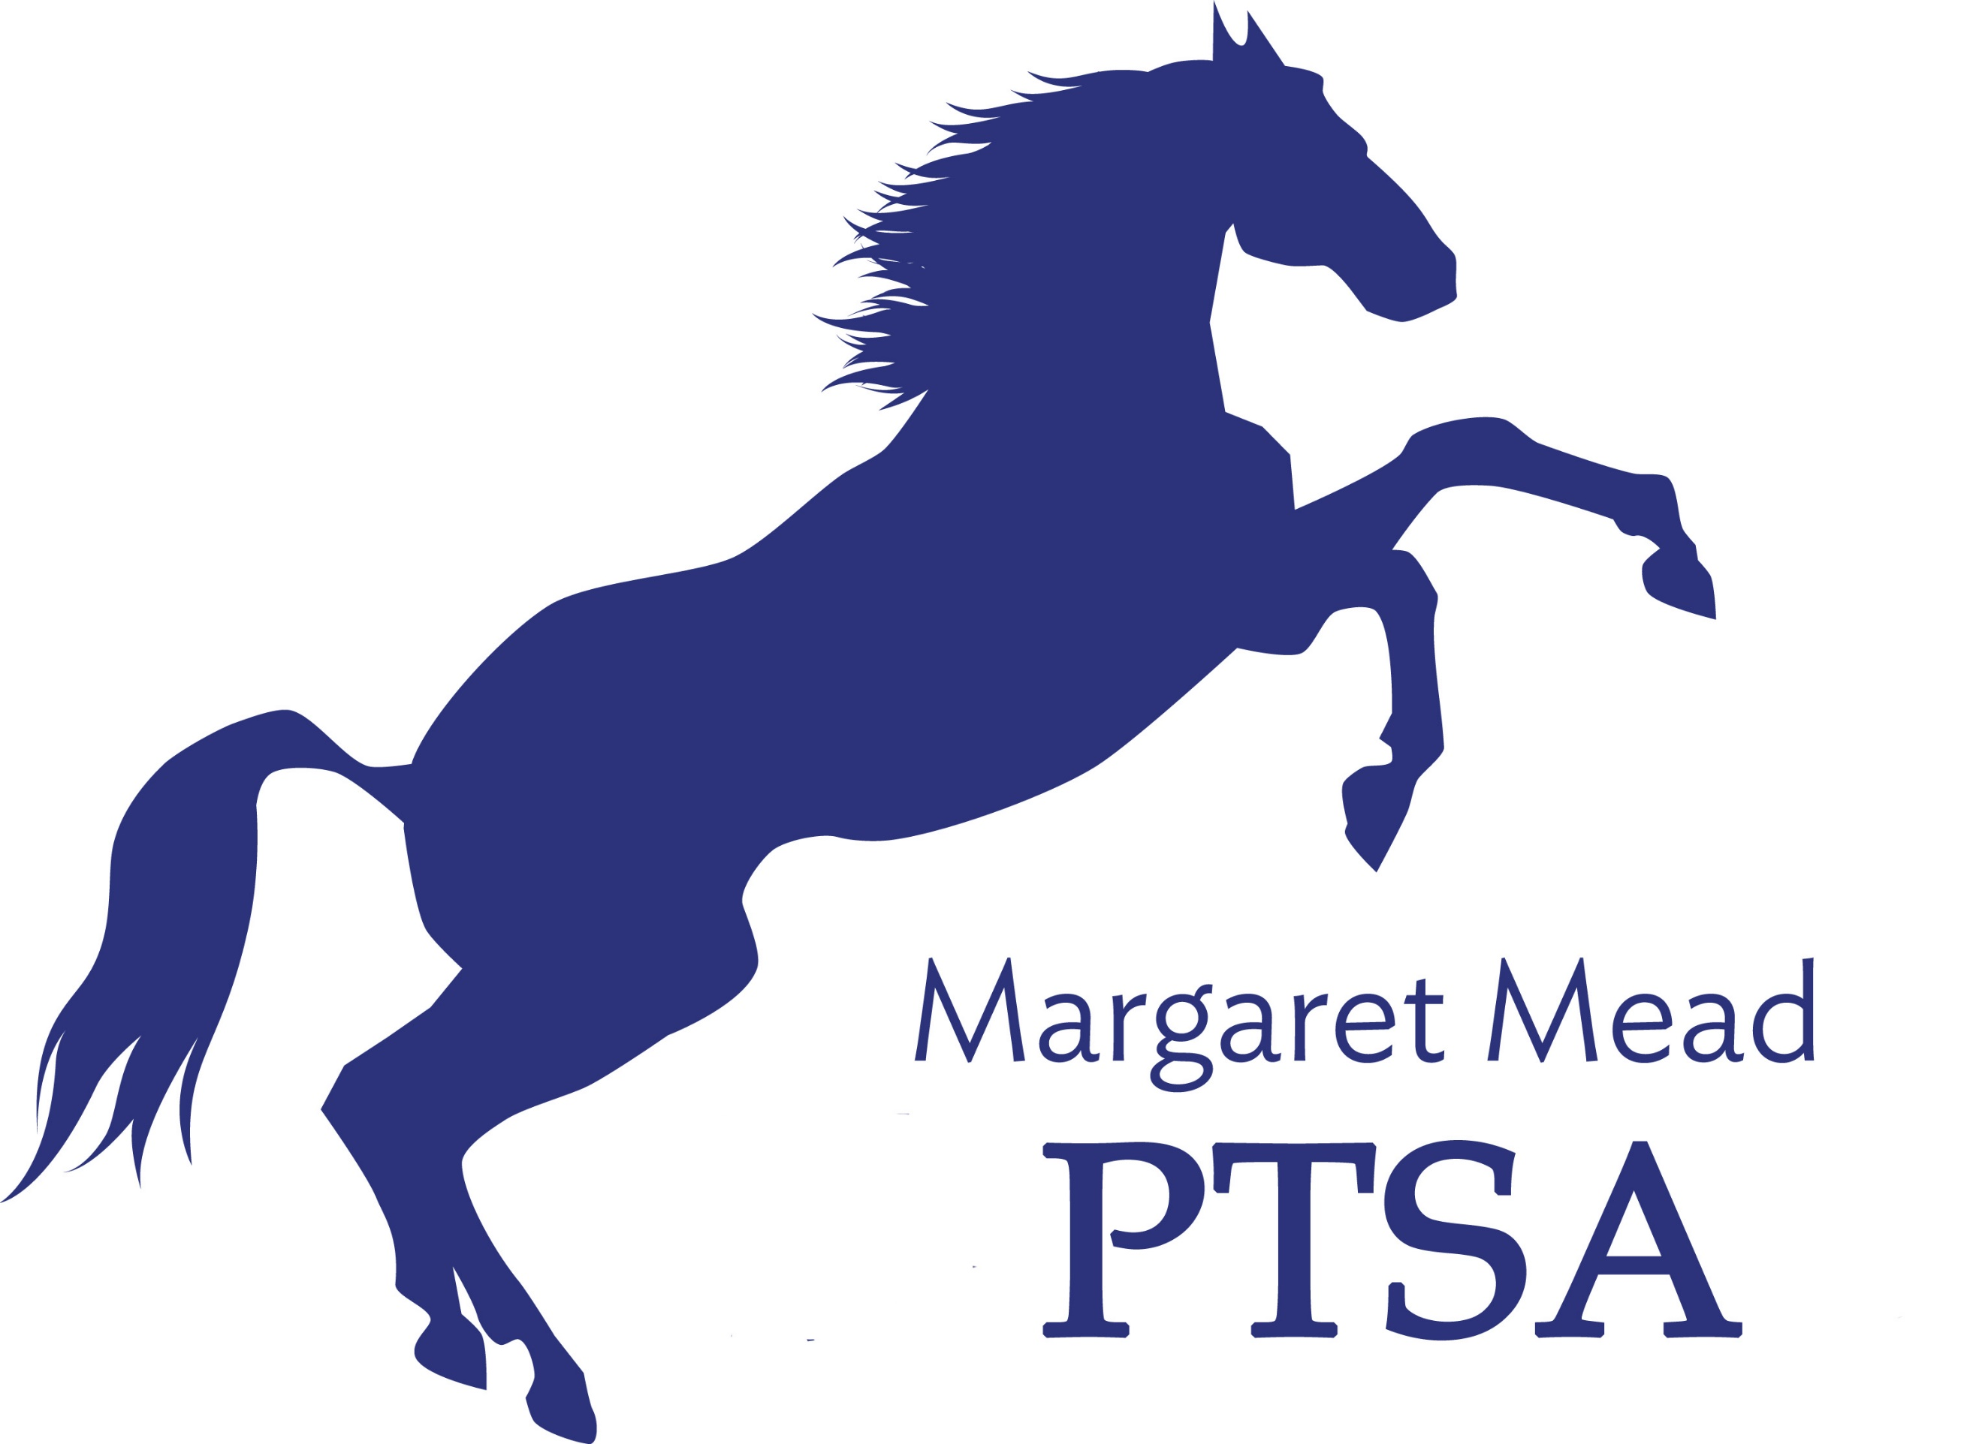
Margaret Mead Elementary PTSA
1725 216th AVE NE, Sammamish, WA 98074
PTSA Unit 2.8.38
www.meadptsa.org
Goals: Support the mission statement using:
effective communication, connecting community, financial support & fiscal responsibility.
General Membership Meeting Agenda
October 1, 2020
- Call to Order
- Approval of the Minutes and Standing Rules
- Executive Board Reports
President: Ryika Hooshangi
- Starting the new school year:
  - Community building focus—virtual events
  - PTSA Website and Facebook
  - Membership
  - Budget
  - Pass the Hat, Amazon Smile and other fundraising events
- Volunteer opportunities
  - Board vacancy—Legislative/Advocacy position
Vice President: Abi Nubla-Kung
- Goals/Mission Statement
- Reflections
Secretary: Leta Hamilton
Treasurer: Molly Hylen
- Treasurer’s Report & Budget Review
- 2019-2020 Mid-Year Financial Audit
- Charitable Solicitations, Insurance Renewal and Tax filing

- Principal/Staff Update
- Adjourn

Next General Membership Meeting-- January 14, 2021 at 7:00pm

Calendar of Events
- Sept. 28-Oct. 2: Spirit Week
- Oct. 6: Math Challenge #1 Due
- Oct. 23: Pumpkin decorating competition
- Nov. 19: Board Meeting
- Dec. 3: Talent Show Night*
- Dec. 16: Margaret Mead’s Birthday
- Dec. 17: Gingerbread House Decorating Competition*
- Jan. 14: Board Meeting and General Membership Meeting
- Jan 21: BINGO/Game Night
- Late Jan/Early Feb: Spelling Bee
- Feb. 4: Board Meeting
- March 4: International Night
- March 11: Board Meeting
- April 15: Board Meeting
- April 29: Virtual Cooking Class
- May 3-7: Teacher Appreciation Week
- May 20: Board Meeting and General Membership Meeting
- June 3: Board Meeting
- June 16: Last Day of School

